

Course title: Machine Learning
Course Code: CSE445
Section: 6

Final Project Report
Speech Recognition System
Submitted by
Group 6
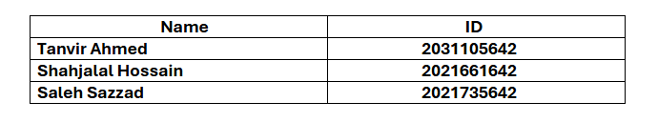
Submitted on
26 November, 2024
Submitted to
M. Shifat-E-Rabbi(MSRb)

Abstract
Speech recognition has become an essential component of modern technology, enabling efficient communication between humans and machines. This project focuses on building a speaker recognition system that identifies individuals based on their voice characteristics. Using logistic regression as the classifier, the system leverages Mel-Frequency Cepstral Coefficients (MFCC) and delta features to extract informative attributes from audio samples. The model achieved validation and test accuracies of 90.00% and 84.34%, respectively. This report discusses the methodology, results, and potential improvements for this system.

Introduction
Speech recognition technology is revolutionizing daily life, from smart home automation to security systems and personal assistants. The goal of this project is to build a machine learning-based speaker recognition system that classifies speakers using their unique voice patterns. We utilized MFCC, delta, and delta-delta features to capture static and dynamic characteristics of speech. Logistic regression was chosen for its simplicity, interpretability, and efficiency in classification tasks. By leveraging a well-organized dataset of 10 speakers, this system demonstrates the practical application of machine learning in speaker identification tasks.

Software Requirements
- Programming Language: Python
- Libraries Used:
  - NumPy, Pandas: For data manipulation.
  - Librosa: For audio feature extraction.
  - Scikit-learn: For implementing logistic regression and evaluation metrics.
  - Matplotlib, Seaborn: For data visualization and confusion matrix plotting.
- Environment: Jupyter Notebook (via Anaconda Navigator).

Why Logistic Regression Over SVM?
- Computational Efficiency: Logistic regression is faster to train and less computationally intensive compared to Support Vector Machines (SVM).
- Scalability: Logistic regression naturally handles multi-class classification problems without the need for complex transformations, making it suitable for identifying 10 speakers.
- Interpretability: Logistic regression provides probability scores for predictions, offering more interpretability than SVM's decision boundaries.
- Baseline Model: Logistic regression is ideal as a baseline model, allowing for rapid experimentation and performance benchmarking before moving to more complex algorithms.

Methodology
The project began with importing necessary libraries, including os, librosa, numpy, sklearn, matplotlib, seaborn, and pickle. These enabled audio processing, feature extraction, machine learning and visualization.
Feature Extraction was implemented using a function to extract MFCC features, along with their delta and delta-delta coefficients. These features, which capture spectral and temporal properties, were averaged into a compact representation for efficient classification.
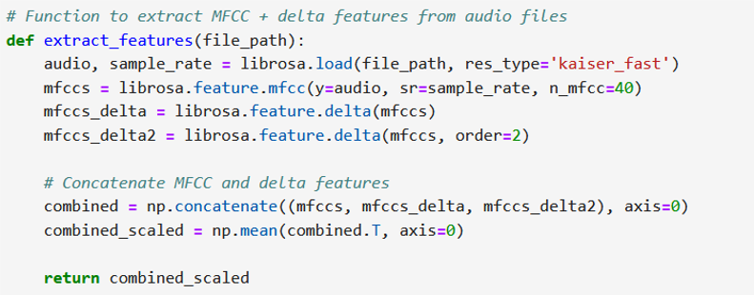
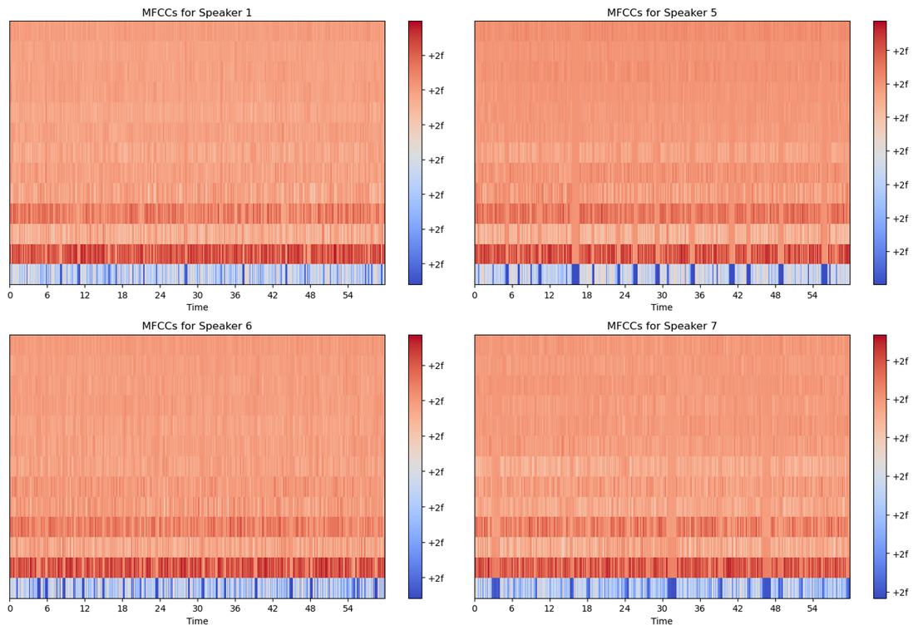

In Dataset Preparation, audio files were organized into subfolders representing speakers. A function iterated through these subfolders, extracted features, and mapped them to speaker labels. The dataset was split into training, validation and test sets for unbiased performance evaluation.
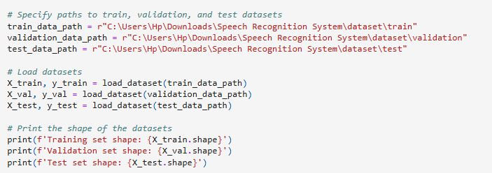

Label Encoding converted speaker names into numerical values using LabelEncoder, ensuring compatibility with machine learning models. The encoding was consistently applied across datasets.
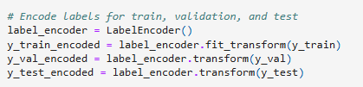

To examine Data Distribution, a bar chart visualized sample counts for each speaker, identifying potential imbalances.
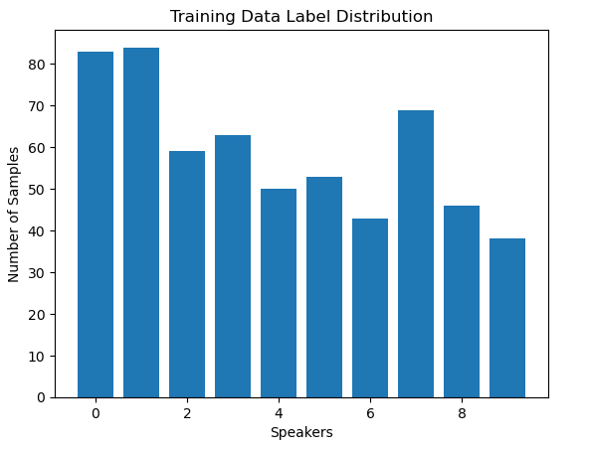
Feature Scaling normalized the data using StandardScaler, standardizing features across datasets to improve training convergence.

A Logistic Regression Model was chosen for its simplicity and efficiency in multi-class classification. It was trained on scaled features with regularization to prevent overfitting.
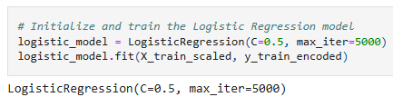

Model Evaluation measured performance on validation and test sets using accuracy scores, ensuring robustness. A Confusion Matrix visualized correct and incorrect predictions which indicates that the model correctly predicted the speaker's label in most cases.
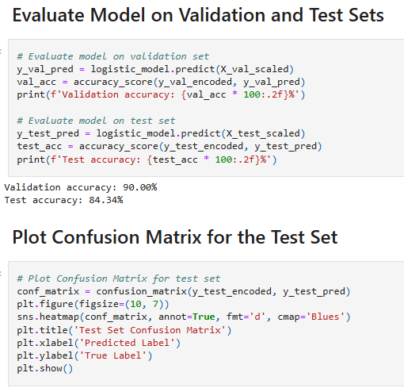
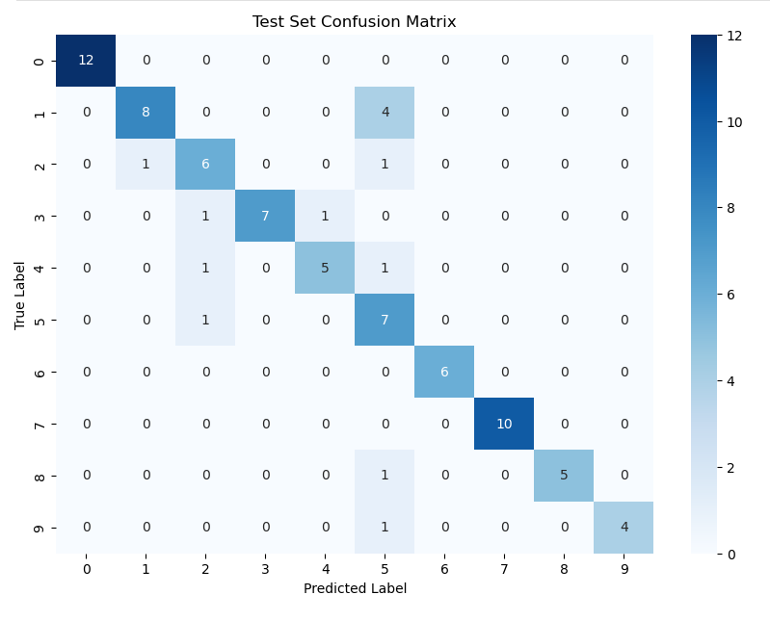
A Speaker Prediction Function was created to process new audio files, extract features and predict speakers using the trained model.
The system was tested with new .wav files through the Speaker Prediction Function, successfully predicting speaker identities.
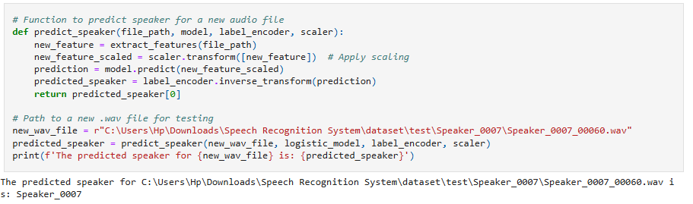
The model was saved with pickle to use in future works.

Results
- Validation Accuracy: The model achieved a validation accuracy of 90.00%, demonstrating strong generalization on unseen validation data.
- Test Accuracy: A test accuracy of 84.34% was observed, with a slight drop due to potential overfitting or the diversity of the test dataset.
- Accuracy Gap: The 5.66% gap between validation and test accuracy suggests areas for improvement in the model's robustness.
- Confusion Matrix Analysis: The confusion matrix revealed occasional misclassifications, particularly among speakers with similar voice features, indicating overlap in their speech patterns.
- Deployment: A prediction function was successfully implemented to classify new audio samples, and the trained model was saved using pickle for deployment.

Discussion
This project demonstrated the feasibility of using logistic regression for speaker recognition. The datasets were split into training (588 samples), validation (170 samples), and test (83 samples). Features like MFCC, delta, and delta-delta coefficients were extracted to represent both static and dynamic voice characteristics.
The logistic regression model with regularization parameter C=0.5 performed well, achieving 90.00% validation accuracy and 84.34% test accuracy. However, the test accuracy drop highlights some challenges:
- Data Diversity: Limited speaker and phrase variety in the dataset may have reduced the model’s ability to generalize.
- Model Complexity: Logistic regression, while simple and efficient, may struggle to capture the intricate patterns present in high-dimensional voice data.

Conclusion
The speech recognition system project successfully demonstrated the use of audio feature extraction and machine learning to identify speakers accurately. By leveraging MFCC and delta features with logistic regression, the system achieved reliable results, highlighting the potential of AI in audio processing. This work provides a strong foundation for future enhancements, such as incorporating advanced models, expanding datasets, and enabling real-time deployment, paving the way for practical and scalable applications.

